# CS 255 System Design Document Template

This template lays out all the different sections that you need to complete for Project Two. Each section has guidance to prompt your thinking. You will need to continually reference the interview transcript as you work to make sure that you are addressing your client’s needs. There is no required length for the final document. Instead the goal is to complete each section based on what your client’s needs are. Remove this note when you are finished, and replace all bracketed text with the relevant information.

## UML Diagrams

### UML Use Case Diagram

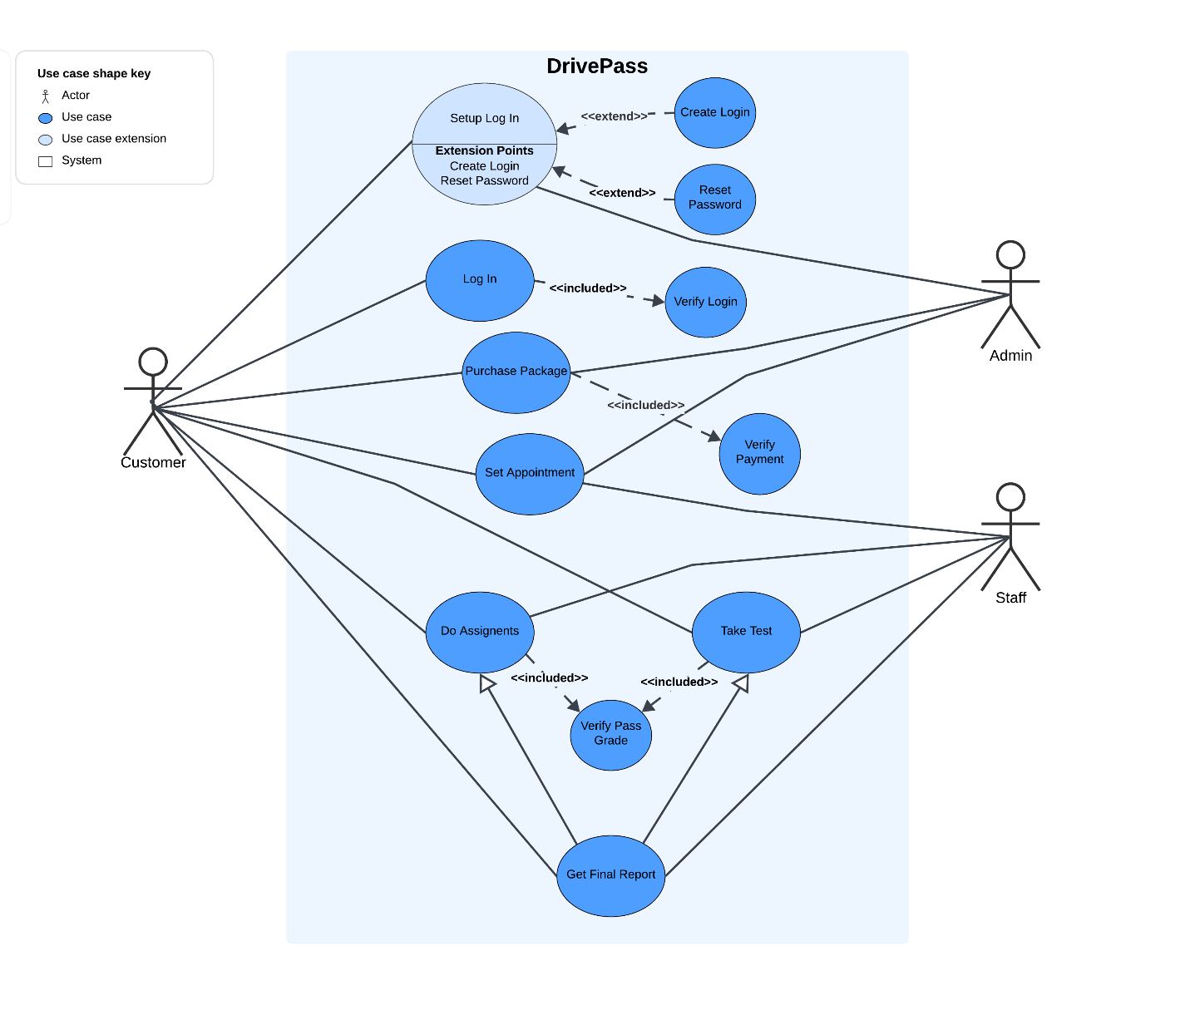

### UML Activity Diagrams

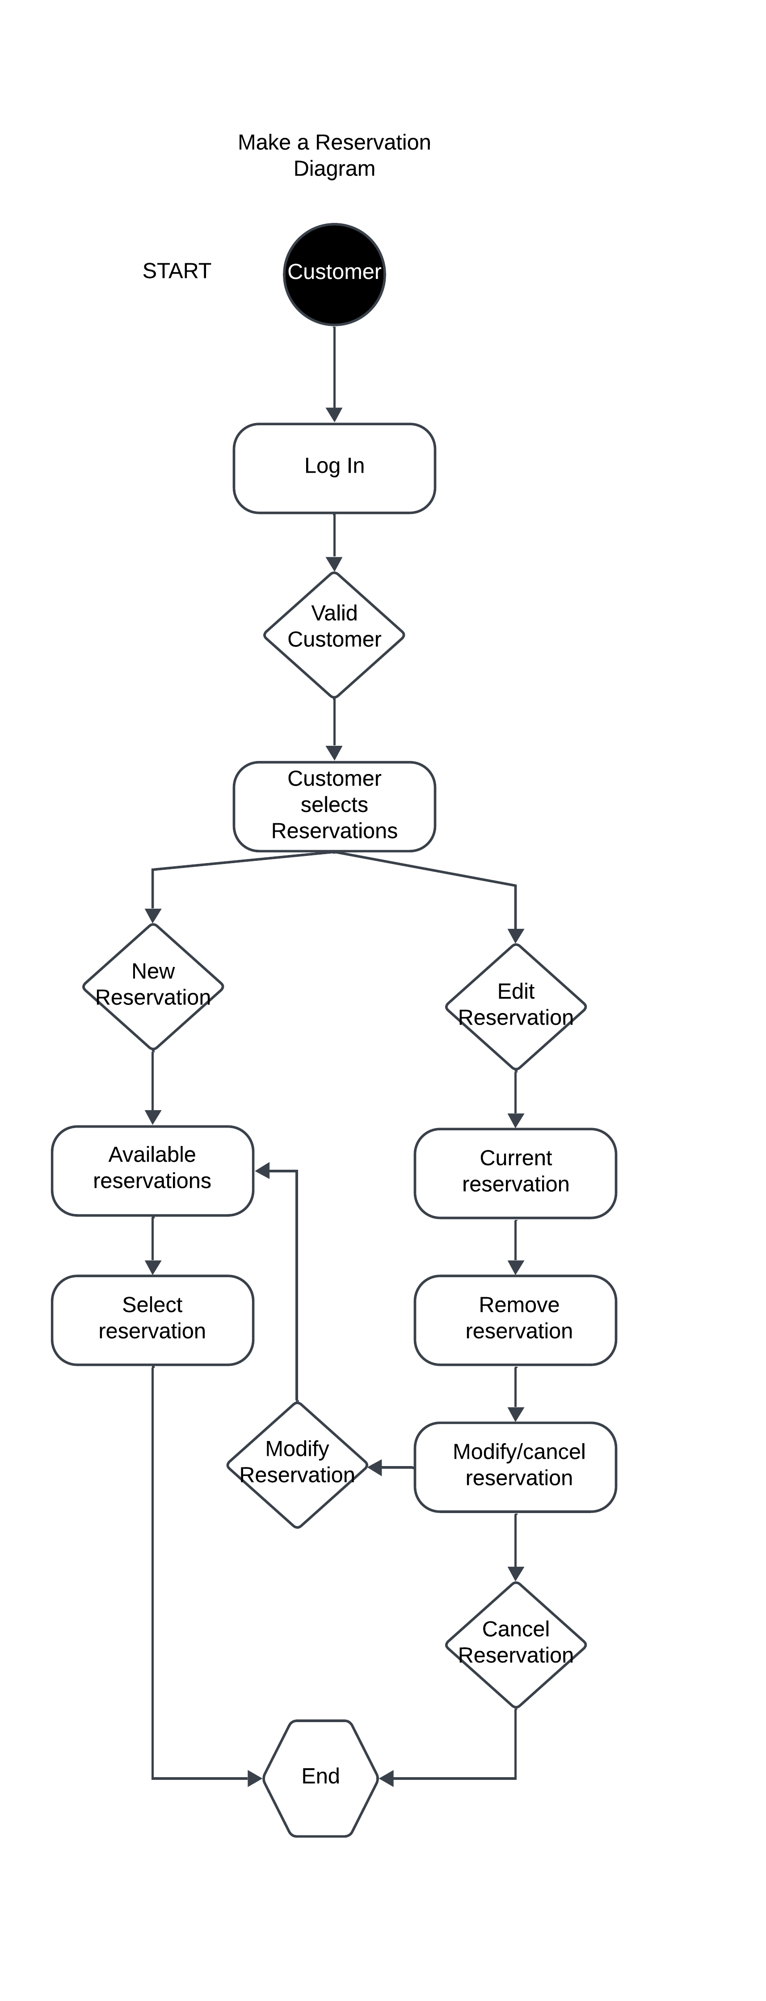

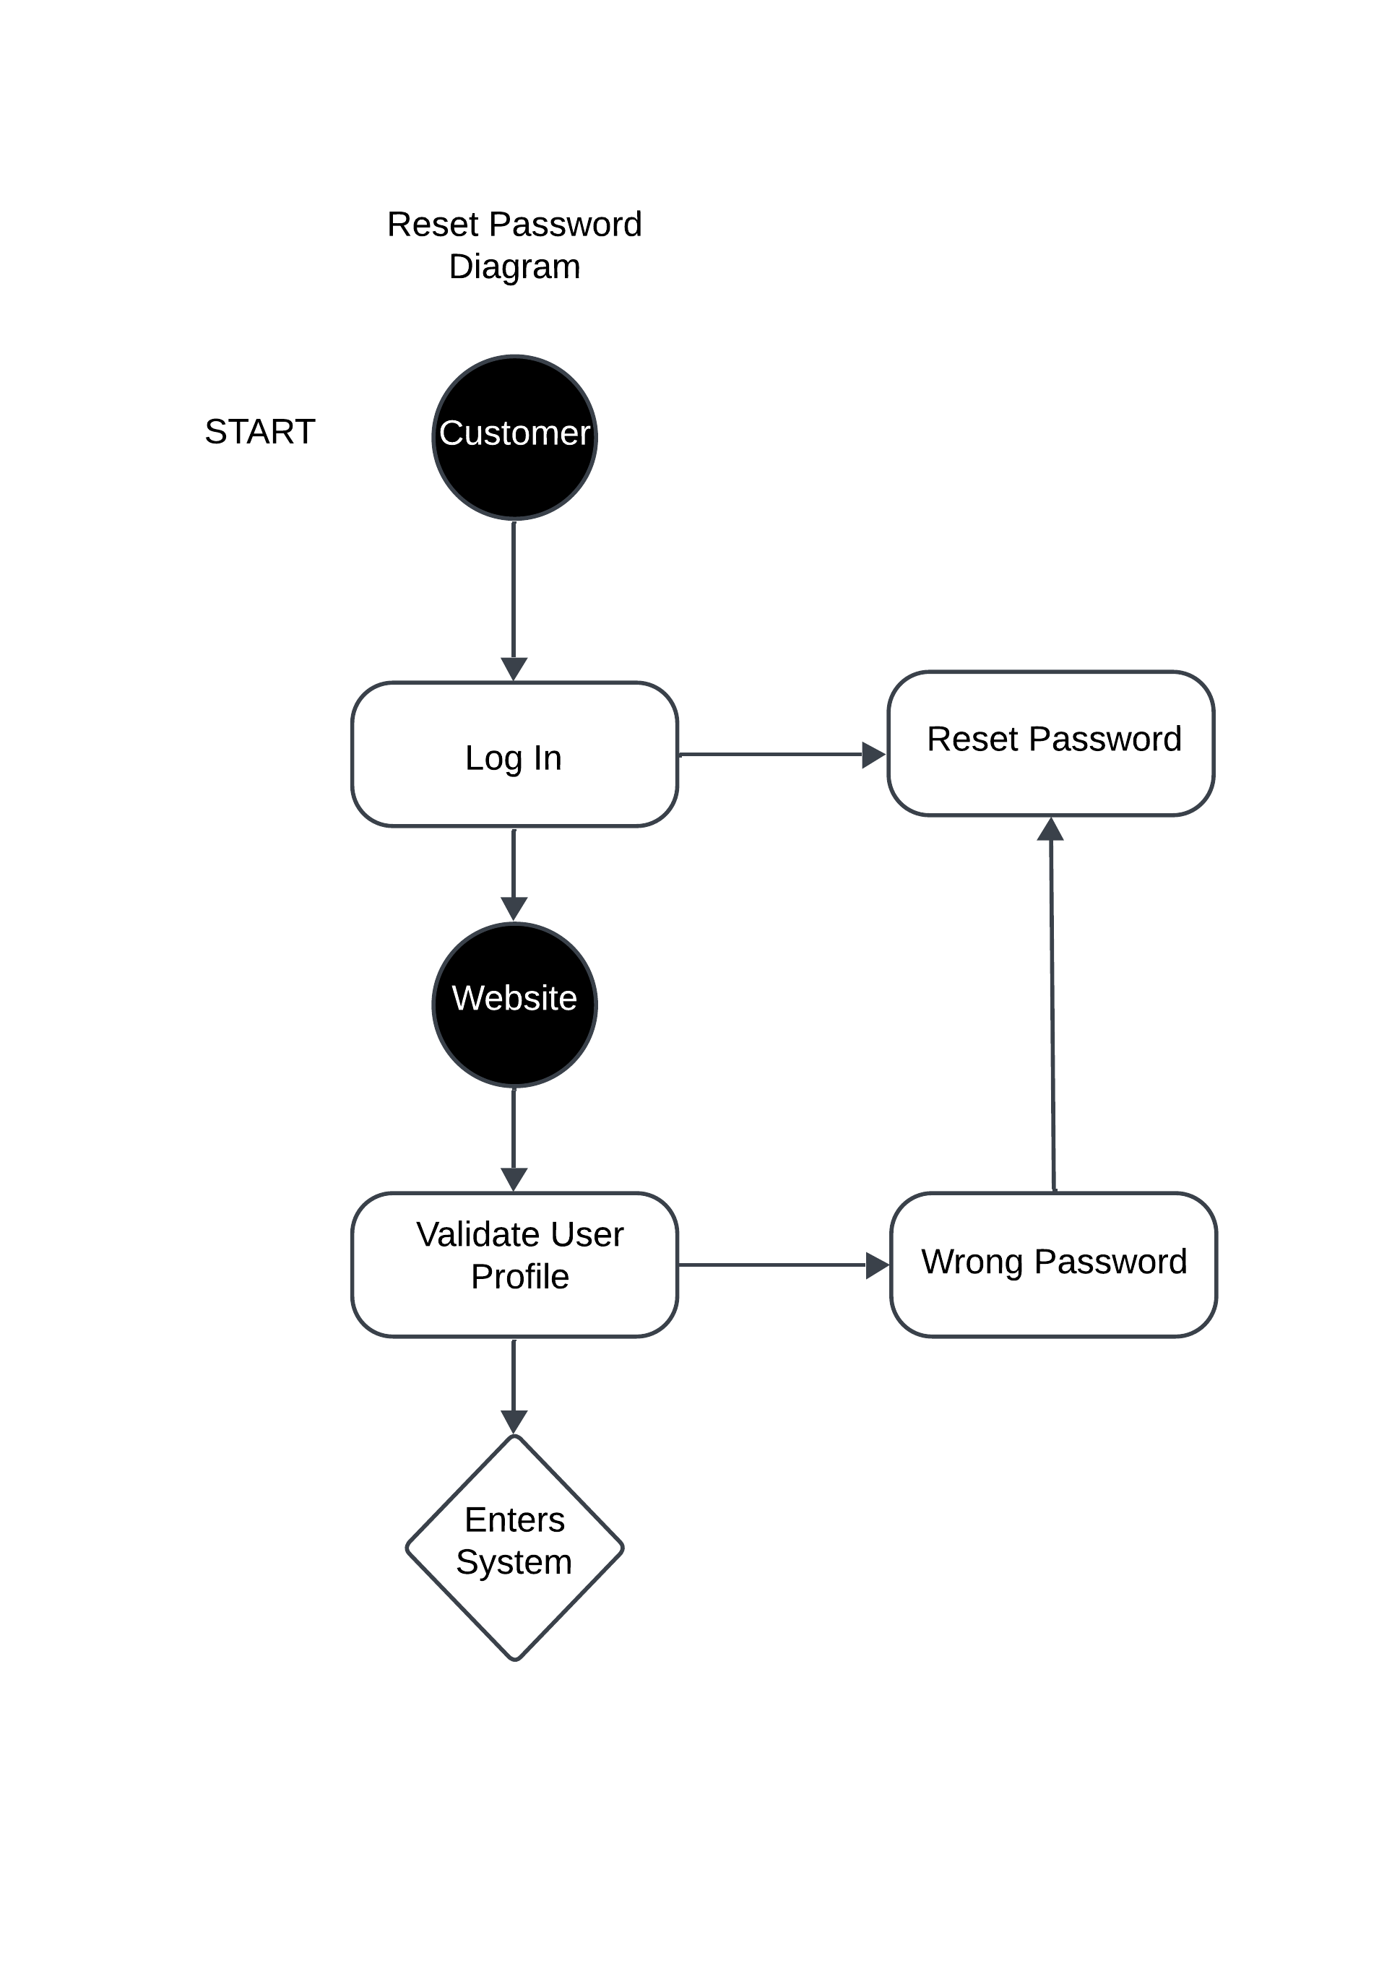

### UML Sequence Diagram

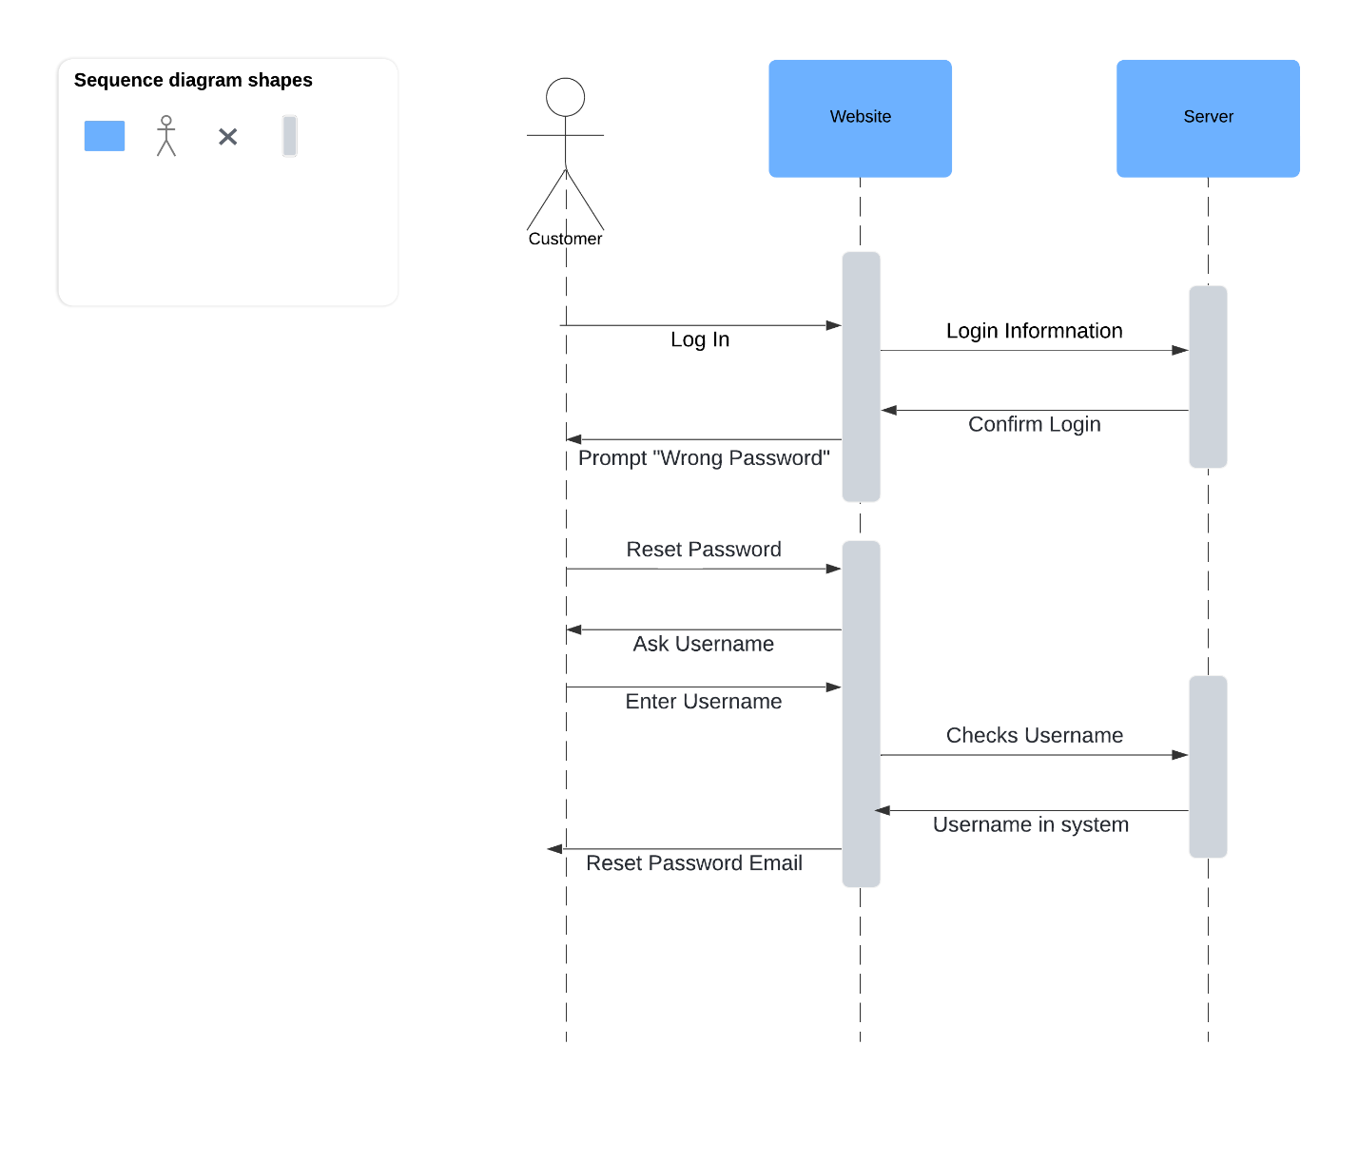

### UML Class Diagram

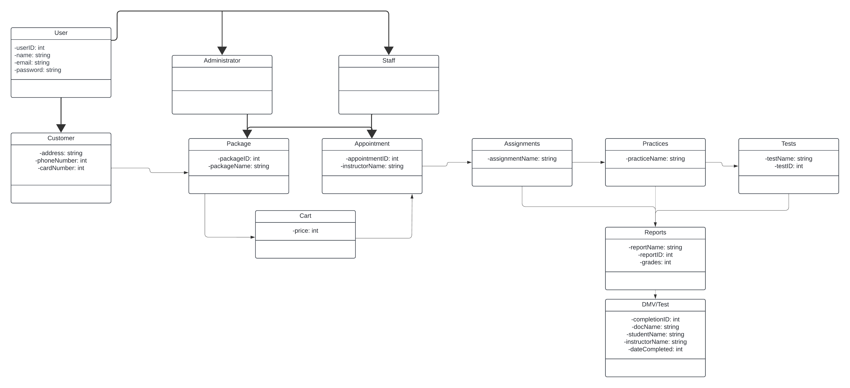

## Technical Requirements

*The requirements for this system should have two separated servers, one being the web hosted server and the other being for the security or backend of the system. The web server will be hosting the UI where users/customers go to login and use the system, this will be a public server. The second server should be all the backend UI for the system, this will be where all the customer information and any accounts used for the system are stored or the extra layer of security. This server is private and should only be available for admin, tech admin and any other access should be monitored. These two servers will run on a cloud service, this being easily accessible for any users using a phone, tablet or desktop. User Interface will be important and will need to be in the web server and be easy to use for anyone wanting to use the system.*